**Conversation Guide: Digital Health Modernization Discovery Research**

**Bold text identify the moderator’s questions.**

*Text in italics are Emily’s observations and interpretations of the participant.*

[Text in brackets are interpretations in participants’ direct quote.]

**Background (5 minutes)**

To get started, I’d like to get a little background information about you, and your experience with the VA.

1. **Can you tell me a little bit about yourself?**

I am 38 or 39, jeez I don’t even know how old I am. *Woman in the background whispers “You’re 38.”* I’m 38 about to be 39.

I have been using the VA health care system since 2007. Recently I transferred to shots instead of medicine for my diagnosis which is bi-polar schizophrenia and that can be kind of… problems there. I can tell you more about that later.

We recently moved to the country in Elwood, and it’s nice out here I love it. I have a son and wife, two cats and a dog. I like to go camping and hunting, obviously, but I haven’t gotten the chance to do that yet. I like the outdoors and to drive. That’s pretty much it.

1. **When did you leave the military?**

Right after the Afghani thing, about 2002-2003.

1. **What VA benefits do you receive?**

100 percent disabled so I get, you know, so much a month and, yeah. I was getting 70 percent at one time, but then I was eligible for 100 but due to not being able to work I get 100. But, if I go back to work it drops to 70. *Participant recognizes that not working impacts his rating and compensation.*

**Health care?** Yes I go to Butler [VAMC] but if I got hurt I would go to Pittsburg, because I don’t think the one in Butler has an emergency room.

1. **Do you have any family members who you claim as dependents?**

Yes I claim both of them on my VA check. My disability check.

**4.a. Do your family members receive any benefits from the VA?** Yes disability.

1. **Do you manage any of your VA benefits online?**

Sometimes I will use the My Vet thing, just to check my appointments and to see if I have messages from my doctors, which I never really get.

I went on a few weeks ago to order a pillow for my back, neck sleeping, but I ended up just giving it to my wife. It’s one of those water pillows, they sent it in the mail to me. It’s kind of cool.

*Participant is referring to ordering medical equipment; which can not be done through MHV. Confirm if he would have used VA.gov or eBenefits?*

1. **Do you use any mobile apps to manage your health?**

Like what? *Moderator prompted Apple Health as an example.* No, I don’t have an Apple phone.

**6.a. VA apps you are aware of:** Just the My Vet thing, and I sometimes go onto the one where you can check your ratings and stuff.

*Moderator showed MHV*: Yes that’s it.

*Moderator showed VA.gov:* Yeah I use VA.gov, yeah that one.

**Mental model of health at the VA (20 minutes)**

Now I’d like to hear about your experience transitioning from the military to the VA. **(10 minutes)**

1. **How did you learn about the health care available to you through the VA, and what was the process of applying for and accessing those benefits?**

I started back in 2007 going to Highland Drive for groups due to mental illness. I think I was eligible; I don’t even know how I was eligible. I was in the military and got out so I pursued the VA healthcare to see if I could get medicine for free and it worked out great.

1. **Did you work with anyone to know what you could receive?**

I had a counselor from the VA; Louise. She helped me through a lot of things.

1. **Do you remember the process?**

It was pretty long because I had to wait a few years to be approved.

1. **When did you apply for disability?**

Well I looked into it and that took a few years to get approved too. I got a backpay check for a few thousand dollars. Then I get social security disability (SSDI) as well.

1. **Did you apply online?**

I think I did, I am not sure it was so long ago.

1. **Tell me about the health care you receive through the VA.**

Well, I have a doctor. Actually when I first moved here I had a doctor; he was okay but he didn’t see me often because he was the main so he gave me a bunch of residents who come in every six months and then leave, so I’d have to re-establish myself with them.

So I saw the resident doctors which was annoying because I wanted a permanent one. That’s why I transferred because now I have a permanent doctor, and psychologists. I normally see my [primary care] doctor once a year, or two if everything is going good. I think I have an appointment coming up soon with her. And then I get my shots [for mental health condition] through the VA as well.

1. **How did you learn Butler VAMC could provide a consistent doctor?**

I think it was my mom that told me that, my mom is a veteran as well. I guess the VA in Butler is smaller so they don’t have doctors that leave often.

1. **Do you use private providers, outside the VA:** Nope
2. **Do your dependents have health care through the VA as well?**

No, we used to have--they were on CHIP but we have cancelled that but it was through the VA as well. It was like $50 a month; we cancelled it because money was tight at the time but now we go through welfare, through UnitedHealthCare.

**How did you figure which on was right for the family:** Her insurance is pretty good; her medicine is pretty cheap and she has been seeing her doctor since our son was born. She likes her doctor a lot. It is like an hour drive but she’s a good doctor. My son is on the same program as my wife.

**Your health through the va and family through a private system:** Well I guess hers is more private because it is a little doctors office and mine is the va which is obviously bigger. Hers has five doctors and the VA has a few hundred .

It is just hers is more convenient. Well mine is too, but it can be a hassle because when I go to get my medicine, it isn’t always ready so I have to come back to see if it is ready.

**Does your wife experience the same thing?** Sometimes because we will call and it won’t be ready. Then my son was in pain and it took two weeks for them to fill it.

**Does she manage it online:** Yeah she does.

**Thoughts about the different between accounts?** They are pretty much the same. Actually, mine’s [MHV is] more in-depth because hers [non-VA] only shows shots and appointments. Mine is more involved.

**Anything yours shows that hers doesn’t:** I am not sure.

1. **Since you first became a Veteran, has there been a change in the types of VA benefits you’ve received?**

I noticed that they changed my shot because the pricing was cheaper than the other shot so I think they try to find the cheapest way to go at the VA.

**Now at 100 percent but wasn’t before, did that change your benefits?** Not really. I just can’t work you know or I will go back down to 70.

**Process to change the rating?** I had to call the number in Cleveland. They had to make a file of it and, see if I was approved or not, and see if I could work.

**How did you find the number:** the regional office provided it to me.

1. **How would you explain a “disability rating” to a new Veteran?**

It is the rating that the VA provides you that rates how disabled you are through the conditions of working, and driving, or being able to function.

1. **In your mind, is there a relationship between “disability” and “health care”?**

Yeah, I think there is. Obviously with health care and disability it coincides because without the disability you wouldn’t have the healthcare, you know.

1. **When it comes to your health care, what is the most important thing you need from the VA?**

I guess my shots because I get them once a month. Without those I would be coo-coo. *This would involve getting timely appointment reminders/communication.*

1. **For your shots, do you make appointments; how do you manage that?**

I go in [to the VAMC] and obviously I check in at the kiosk. Then I got to the blood lab because they test me each month to make sure I am clean. Then I go to the waiting room and wait to be called. Then when I’m done they will ask when I want to be seen again, like what day of the week. Then I go to the front desk and they write me up a note or a slip, and then I will be on my way.

**Ever make the appointment outside of in person:** Sometimes I will call to find out when my appointment is.

*Participant prefers in-person or over the phone to make an appointment.*

Now I’d like to ask you how you manage information and tasks related to your health care. For each one, talk me through the steps you’d take. If there is something that you go online to complete, I may ask you to share your screen so I can see what you would do. **(10 minutes)**

**Tasks** Moderator should prompt about device usage if participant mentions digital tools or resources.

* **How would you reach out to your VA care team if you had a question?**

I would probably call the nurses hotline or I would google the number because I don’t have them saved. I would call then it would go through the prompts and leave a message to get a call back.

* **Google to find the number:** go to google then type in VA butler phone number. *Participant opens Safari on iPad and searches. Google displays 800 number at top of results.* That’s what I would do.
* **Do you ever use My HealtheVet for your appointments**: Sometimes. *Participant exits Safari and looks through home page of his iPad. Flips through multiple screens of apps.* I’m trying to find…if I have it on here, I think I do. Oh wait it’s on my other iPad, actually the one that they gave me. The VA, they gave me an iPad for my appointments. *Assuming the participant was looking for VAOS app?*
* **I guess we won’t be able to see that today** I could try and type in… *Participant returns to Safari and types “my” in google search bar. Top 3 terms are my va health; my va benefits; my healthevet.*

Would it be my healthy vet, or health benefits? *Moderator prompts my healthevet.*

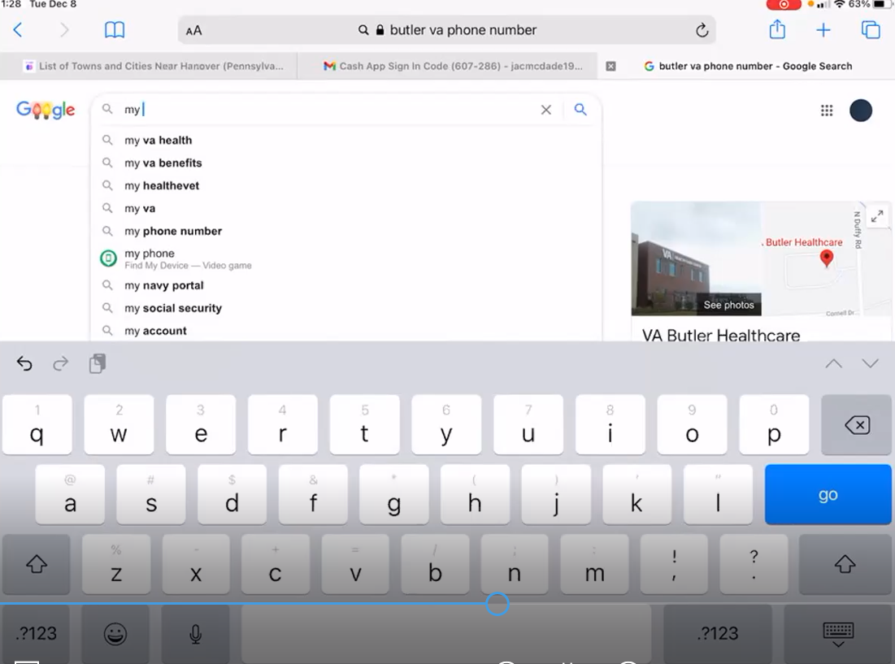

*Participant signs in using DS Logon. Types in his user name and password, but receives an error. First goes through ‘Forgot Username’ flow then ‘Forgot Password’. Moderator begins to ask if participant wants to stop sharing, or stop recording, but participant responds no no, ‘you’re fine.*

*Moderator asked if on the other iPad, if he logged in using Safari as he was doing now. Participant said yes, however he initially looked through his apps when asked about going online. Participant successfully logs into My HealtheVet.*

**We were talking about checking your appointments.** Yep. *Participant clicks on View all Appointments* link from homepage Appointments tile.

**Do you usually use this [website]?** Sometimes, I will go on and look but I don’t think I have anything right now. *Participant scrolls down only to the Cerner alert, which on his iPad has now been pushed below the side navigation “Get Care” on the left side of the screen, pushing the appointments table further down. Participant does not scroll past the yellow alert, and assumes he has no appointments on this page.*

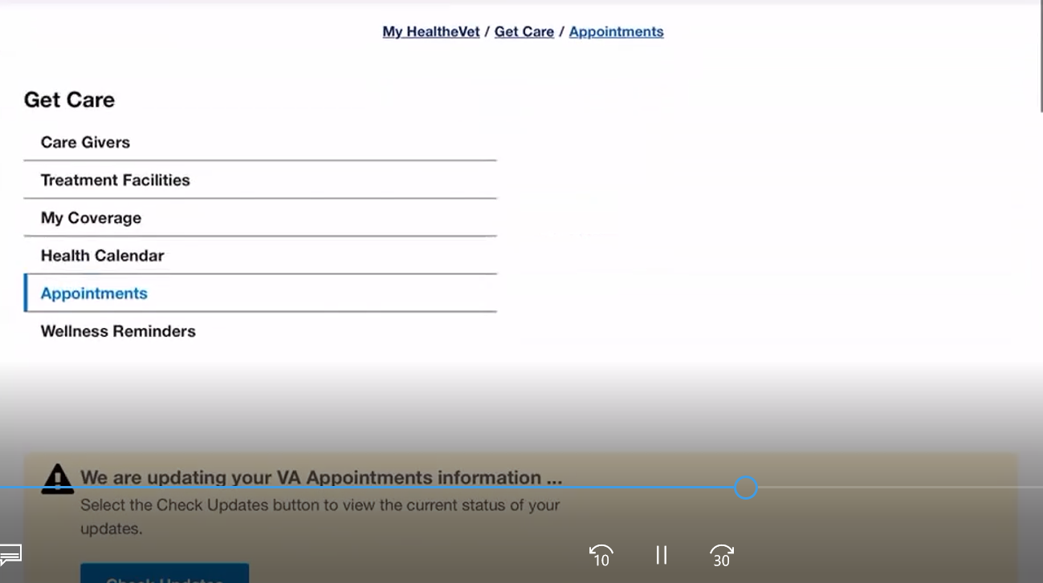

And it tells me the caregivers. *Participant clicks on Care Givers link in side nav under Get Care. Scrolls up and down the page when he sees an empty table. Participant is silent as he scrolls.* It should…

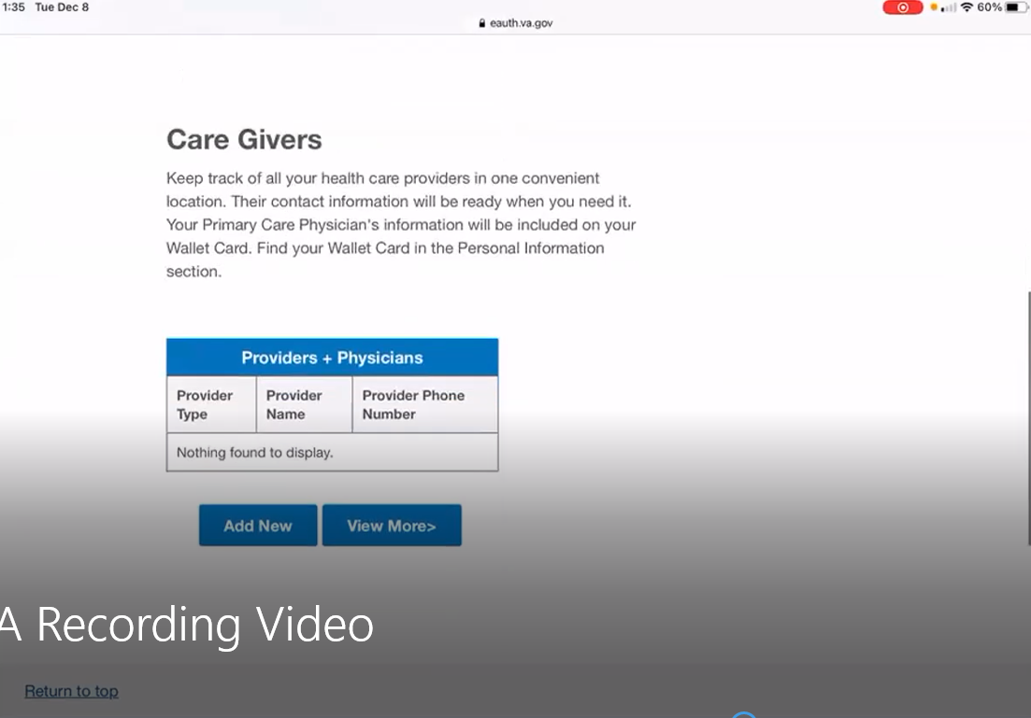

**What is normally on this page?** It usually says me my care givers, my providers. *Participant reads aloud the text in the Care Giver table “Nothing found to display.”* Huh. That’s odd.

Treatment facilities… *Participant clicks on Treatment Facilities link in left side nav under Care Givers. This table is also empty.* Ok.

* **How would you refill a prescription you have with the VA?**

*Participant leaves Safari, then re-opens. He opens a new page on the browser, and types in VA Butler Pharmacy.* Pretty much I would google and type in butler VA Pharmacy. Then their number is right there.

**Once you call is there anything else you do:** It goes right to the pharmacy and I type in the medication I need through the phone.

* **How would you go about checking the date of an upcoming medical exam you have for a disability claim?**

*Participant is confused by the question, moderator repeats. It’s been more than 10 years since this was applicable for the participant.* Probably type in VA regional office phone number then I would call their 800 number. That’s the one I called for the disability rating thing.

**How did you know to call them:** I called Pittsburgh first and was told to call Cleveland because they handle it.

* **If your wife or son had an appointment with their doctor, how would you check when it was?**

*Participant types in the name of his wife’s doctor in Google search bar.* I would go to that. *Points to the phone number next to the Google Map result.*

* **Co-pay:** N/A.
* **How would you request reimbursement from the VA for traveling to your health care appointments?**

Sometimes I do. I do it on the kiosks which is really nice. It will say request travel and I sign it and it automatically sends it to the travel agent. It is at the VA. It is right when you walk in to check into the appointment, you can request travel from there as well.

**How do you like it:** it is nice and convenient whereas before you had to wait until after the appointment then go to the travel office, they’d give you a slip, you sign it and then it automatically sends [the money] to the bank.

**Where is the travel agency?** it is around the corner but I never use it because of the kiosk. In another office within the VA building.

**How would you update the dependents on your VA benefits?** I would call the regional Pittsburgh office on the 17th floor for stuff like that.

**How would you make updates to your health care benefits?** Probably call my doctor and tell them.

**Branding and trust (5 minutes)**

Now I’d like to ask for your thoughts on My HealtheVet. (Confirm that participant has used My HealtheVet previously. If not, amend questions below to capture their first impressions while looking at a logged in account.)

1. **How would you describe My HealtheVet to a fellow Veteran?**

Well I would say it is self-explanatory. You pretty much can go to your benefits and stuff.   
  
*Participant clicks on Benefits link under Resources on the MHV homepage; redirects to VA.gov. Participant does not seem to notice that he has been redirected to VA.gov and is no longer on MHV.*

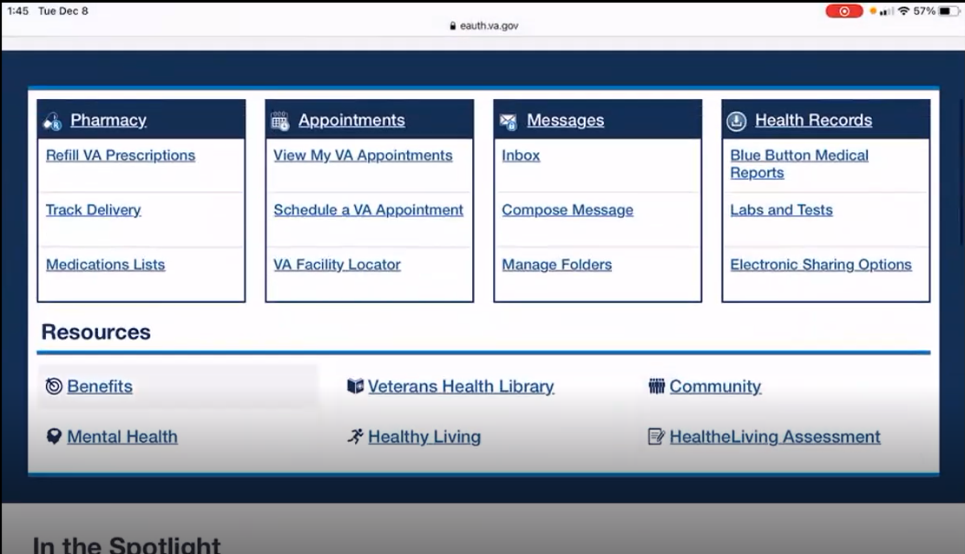

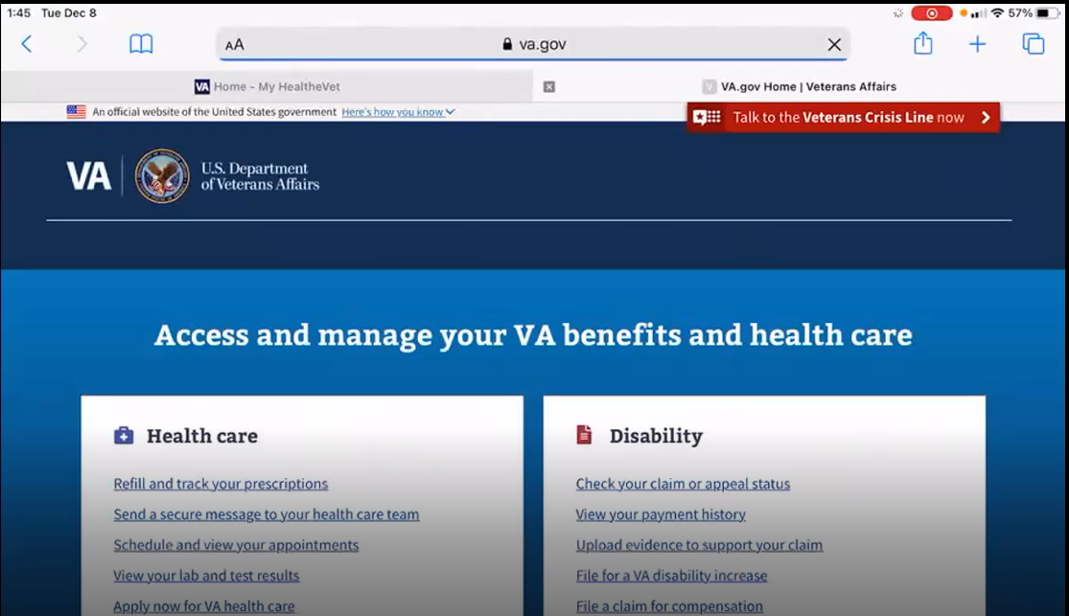

Then give a list of stuff and the categories explain what it is. *Participant is looking at the four benefit hubs on the VA.gov home page.* Actually it is nice because they make it so that you can read it well. Yeah I like it.

**When you say you can read it easier, what do you mean?** It is more like self-explanatory. It breaks it down, for what to look for. It is easy to find stuff on it.

1. **What about “VA health care?”**

I would say it is like, the doctors are nice, they have your back and kind of look after you. They pretty much care for you and umm I just didn’t like the fact I was getting a new doctor each year and have to explain the life history after each year.

1. **On a scale from 1-5, with 1 being very dissatisfied, and 5 being very satisfied, how satisfied are you with My HealtheVet?**

5.

**What makes you rate it a [their rating]?** Just that it is easy to use, self-explanatory like I said. I find it useful to check on claims/appeals, payment history. You know stuff like that. *Participant seems to be reading the first links under Disability on VA.gov homepage (see above screen shot).*

1. **On a scale from 1-5, with 1 being very low, and 5 being very high, how would you rate your trust in My HealtheVet?**

A 5 as well.

**What makes you rate it a [their rating]?** Just because it is confidential, I don’t think anyone could get onto my site [unless] they had my password. It is pretty confidential.

**Anything else:** Not really, I don’t know.

1. **If you have a question about your MHV account or something isn’t working, what do you do?**

Good question… I would probably write a letter to the regional office saying I have an issue with myhealthevet and give them my phone number. And hope they could fix it.

1. **Have you ever been in touch with a My HealtheVet Coordinator?**

*Participant was not familiar with this term.* Actually I had someone helping me look for a job through the VA at one point. This was when I wasn’t 100 percent disabled. They come to your house to talk with you and take you to look for a job and assist with the process. It is kind of cool.

1. **How does My HealtheVet compare with other online health tools you’ve used?**

It is pretty easy I mean you type in what you need to know and it gives you your answer.

**My HealtheVet patient portal (15 minutes)**

Let's take a look at My HealtheVet together.

Moderator will ask participant to share screen if not already, or show logged in My HealtheVet account. **(5 minutes)**

*While on VA.gov, moderator asked participant to navigate back to MHV; participant did not seem to understand. Moderator tried to call attention to the MHV tab in Safari, next to VA.gov, but the participant was still confused. Eventually moderator prompted ‘My Health’ to navigate back to MHV. Participant did not comment on the redirect or difference between the two sites.*

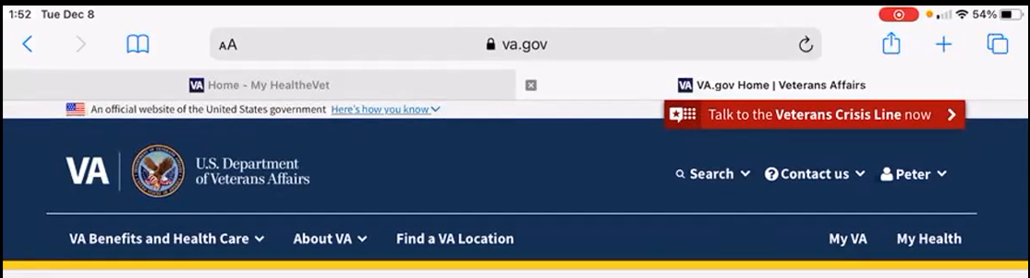

1. **What do you use this website for the most?**

To keep track of my appointments, medicine, and doctors, see if they have any messages for me, and lab tests. I have gout, so I’d probably look under the lab tests to see what the results were. I know the medicine I need so I wouldn’t look at the refill prescriptions. I probably could but I don’t know if I would.

*Participant clicks into Refill VA Prescriptions under Pharmacy on the homepage.*

**Anything that looks useful here?** Active refill remaining, 6 refills remaining. There’s the medication that they changed, tis the second one, its every two months.

**Have you used this button “Track Delivery”:** No I haven’t actually.

1. **What do you find the most valuable on this website?**

The whole website? Pretty much my personal information … *Again, participant seems to be reading from the website.* *Participant hovers on Personal Information from top nav.*

Like my DD-214, award letters stating my disability and stuff. They would be the most important things on there. *Participant uses top nav to look for this; hovers on Pharmacy. Goes back go MHV homepage. Returns to Personal Information in top nav.*

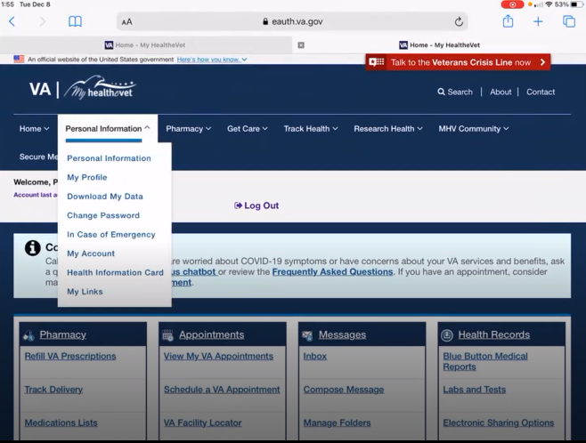



**Why:** Just so I know where it is at and how to find it in case I need to provide someone with it.

1. **What do you wish this website did that it doesn’t do right now?**

Talk back to you. *Participant laughs.* Where if you had a questions and needed help I wish it could talk to you. That would be kinda cool.

**Have you had that before:** Not really.

1. **Outside of this website, are there other places you go to manage your VA health care?**

Pretty much this one. *Participant still on MHV.* And then like I said when I go to the VA I get the pieces of paper that tells me when my next appointment is and I put it on my calendar.

1. **When it comes to your My HealtheVet account, can you think of a time when you needed to give access to a family member or someone else?**

*Moderator’s question was confusing, participant provided example of when someone needed information and the participant logged into their account to get it.* Actually when the VA was helping to fix my car I had to come on here to get my disability rating and my dd214. Then I had to print it out and send it to them. I forget the program that helped me with my car, they gave me $600 for my car.

**Thank you and closing (2 minutes)**

**Any additional feedback or questions?** Not really I can’t think of anything.